Classwork Chapter 6

**Heat and Work**

1. Calculate q released when 33 grams of water is cooled from 125 C to -14C.

2 Which of the following process release energy:

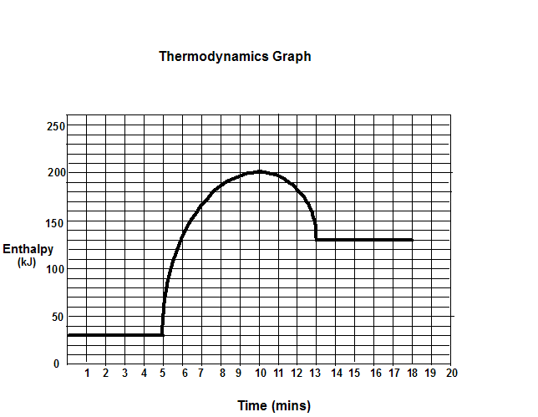

Boiling, condensation, freezing, melting, evaporation.

**Enthalpy**

3.

_______a. This is a(n) (endothermic, exothermic) graph.

_______b. Potential energy is (increasing, decreasing).

_______c. The surroundings are getting (hotter, colder).

_______d. The reaction is (releasing, absorbing) energy.

_______e. The enthalpy (H) of the reactants is ? kJ.

_______f. The enthalpy (H) of the products is ? kJ.

_______g. The change in enthalpy (H) of the reaction is ? kJ.

______ h. The (products, reactants) have more

potential energy.

USING THE FOLLOWING TABLE OF BOND ENERGIES, CALCULATE THE CHANGE IN ENTHALPY FOR THE FOLLOWING.

H-H 104 kcal

H-Cl 103 kcal

Cl-Cl 58 kcal

C-H 87 kcal

O-H 111 kcal

O=O 118 kcal

C=O 176 kcal

C-Cl 79 kcal

C=C 148 kcal

____________4. 2H2(g) + O2(g) → 2H2O(g)

____________5. CH4(g) + 2O2(g) → CO2(g) + 2H2O(g)

____________6. C2H4(g) + Cl2(g) → C2H3Cl(g) + HCl(g)

Cl H

| |

C = C

| |

H H

**7. DETERMINE IF THE FOLLOWING ARE EXOTHERMIC (exo) OR ENDOTHERMIC (endo).**

________a. Reaction releases heat ________e. Products have more enthalpy (heat) than reactants  
________b. Energy is found as a reactant ________f. Reactants have more enthalpy (heat) than products.

________c. Energy is found as a product ________g. H is a (-) value.

________d. H is a (+) value ________h. Reaction absorbs heat.

USING THE INFORMATION IN THE FOLLOWING TABLE, DETERMINE THE Ho FOR THE REACTION.

CO(g) Ho =-26.4 kcal/mole

CO2(g) Ho =-94.1 kcal/mole

Fe2O3(s) Ho =-197 kcal/mole

Fe3O4(s) Ho =-267 kcal/mole

FeO(s) Ho =-63.7 kcal/mole

____________8. 3Fe2O3(s) + CO(g) → 2Fe3O4(s) + CO2(g)

____________9 Fe3O4(s) + CO(g) → 3FeO(s) + CO2(g)

____________10. FeO(s) + CO(g) → Fe(s) + CO2(g)

____________11. Given the following data, calculate the H for NaHCO3(s)

**2NaHCO3(s) → Na2CO3(s) + CO2(g) + H2O(l)**

Ho reaction = 30.92 kcal/mole Ho Na2CO3 = -270.3 kcal/mole

Ho CO2 = -94.0 kcal/mole Ho H2O = -68.4 kcal/mole

**Hess’ Law**

____________12. Calculate H for the reaction: C2H4 (g) + H2 (g)  C2H6 (g), from the following data.

|  |  |
| --- | --- |
| C2H4 (g) + 3 O2 (g)  2 CO2 (g) + 2 H2O (l) | H = -1411. kJ |
| C2H6 (g) + 3½ O2 (g)  2 CO2 (g) + 3 H2O (l) | H = -1560. kJ |
| H2 (g) + ½ O2 (g)  H2O (l) | H = -285.8 kJ |

____________13  Calculate H for the reaction 4 NH3 (g) + 5 O2 (g)  4 NO (g) + 6 H2O (g), from the following data.

|  |  |
| --- | --- |
| N2 (g) + O2 (g)  2 NO (g) | H = -180.5 kJ |
| N2 (g) + 3 H2 (g)  2 NH3 (g) | H = -91.8 kJ |
| 2 H2 (g) + O2 (g)  2 H2O (g) | H = -483.6 kJ |

____________14. Calculate H for the reaction CH4 (g) + NH3 (g)  HCN (g) + 3 H2 (g), given:

|  |  |
| --- | --- |
| N2 (g) + 3 H2 (g)  2 NH3 (g) | H = -91.8 kJ |
| C (s) + 2 H2 (g)  CH4 (g) | H = -74.9 kJ |
| H2 (g) + 2 C (s) + N2 (g)  2 HCN (g) | H = +270.3 kJ |